《Python编程》课程
实验报告六 面向对象编程—继承
班级：计算机2002班 学号： 20203202237 姓名： 徐喆锴

一、实验目的和要求
掌握继承的概念和用法；
掌握单继承的使用；
掌握多重继承的使用。

二、实验内容
1分别定义Shape类、Circle类和Cylinder类并创建对象，编写程序对各自的功能进行测试。
2定义Clock类，实现时钟的基本功能；
定义Calendar类，实现日历的基本功能；
定义CalendarClock类，同时实现日历和时钟的功能。
编写程序，创建各自对象，并进行测试。

一、给出实验内容1，2的具体代码和程序运行结果截图。
实验内容1
class Shape:
def __init__(self, sh, name):
self.__name = name
self.__sh = sh

def __repr__(self):
return self.__name + ' is ' + self.__sh

def getName(self):
return self.__name

def getShape(self):
return self.__sh

class Circle(Shape):
def __init__(self, name: str, radius: int, sh='Circle'):
super().__init__(sh, name)
self.__name = name
self.__sh = sh
self.__radius = radius

def getRadius(self):
return self.__radius

def setRadius(self, radius):
self.__radius = radius

def __repr__(self):
return "{}'s radius is {}" \
.format(self.__name, self.__radius)

class Cylinder(Shape):
def __init__(self, name: str, height, radius, sh="Cylinder"):
super().__init__(sh, name)
self.__name = name
self.__sh = sh
self.__height = height
self.__radius = radius

def __repr__(self):
return "{}'s radius is {}, height is {}" \
.format(self.__name, self.__radius, self.__height)

def getRadius(self):
return self.__radius

def getHeight(self):
return self.__height

def setRadius(self, radius):
self.__radius = radius

def setHeight(self, height):
self.__height = height

a = Shape('none', 'a')
b = Circle('b', 5)
c = Cylinder('c', 10, 5)
print("{} is {}\n{}'s radius is {}\n{}'s radius is {}, height is {}"
.format(a.getName(), a.getShape(), b.getName(), b.getRadius(), c.getName(), c.getRadius(), c.getHeight()))
b.setRadius(10)
c.setRadius(20)
c.setHeight(11)
print("{}\n{}\n{}".format(a, b, c))
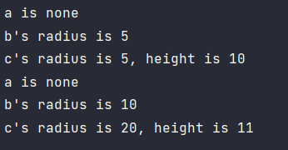
实验内容2
class Clock:
def __init__(self, time: list = None):
if time is None:
time = [0, 0, 0]
self.__time = time

def getData(self):
return self.__time

def __repr__(self):
return 'It is {0[0]}:{0[1]}:{0[2]} now'.format(self.__time)

def setTime(self, time: list = None):
if time is None:
time = [0, 0, 0]
self.__time = [0, 0, 0]
self.passTimeT(time)

def passTimeT(self, time: list = None):
if time is None:
time = [0, 0, 0]
hour, minute, second = time[0], time[1], time[2]
self.__time[2] += second
self.__time[1] += self.__time[2] // 60 + minute
self.__time[0] += self.__time[1] // 60 + hour
tmp = self.__time[0] // 24
self.__time[0] %= 24
self.__time[1:] = list(map(lambda x: x % 60, self.__time[1:]))
return tmp

# 未考虑大小月，是否闰年，统一按一月30天，一年十二月计算，因此存在误差
class Calendar:
def __init__(self, date: list = None):
if date is None:
date = [1970, 1, 1]
self.__date = date

def getData(self):
return self.__date

def setDate(self, date: list = None):
if date is None:
date = [0, 0, 0]
self.__date = [0, 0, 0]
self.passTimeD(date)

def __repr__(self):
return "It is {0[0]}.{0[1]}.{0[2]}" \
.format(self.__date)

def passTimeD(self, date: list = None):
if date is None:
date = [0, 0, 0]
year, month, day = date[0], date[1], date[2]
self.__date[2] += day
self.__date[1] += self.__date[2] // 30 + month
self.__date[0] += self.__date[1] // 12 + year
self.__date[2] %= 30
self.__date[1] %= 12

class CalendarClock(Clock, Calendar):
def __init__(self, time: list = None, date: list = None):
super().__init__()
if time is None:
time = [0, 0, 0]
if date is None:
date = [1970, 1, 1]
self.__time = time
self.__date = date

def __repr__(self):
return "It is {0[0]}.{0[1]}.{0[2]} {1[0]}:{1[1]}:{1[2]} now" \
.format(self.__date, self.__time)

def getData(self):
return self.__date, self.__time

def setCalender(self, time: list = None, date: list = None):
if time is None:
time = [0, 0, 0]
if date is None:
date = [0, 0, 0]
self.__time = [0, 0, 0]
self.__date = [0, 0, 0]
self.passTimeC(date, time)

def passTimeC(self, date: list = None, time: list = None):
if date is None:
date = [0, 0, 0]
if time is None:
time = [0, 0, 0]
clo = Clock(self.__time)
da = Calendar(self.__date)
date[2] += clo.passTimeT(time)
da.passTimeD(date)
self.__time = clo.getData()
self.__date = da.getData()

if __name__ == '__main__':
aClock = Clock()
aCalen = Calendar()
aCaClo = CalendarClock()
print("{}\n{}\n{}\n".format(aClock, aCalen, aCaClo))
aClock.passTimeT(list(map(int, input("Input time to pass(h,minute,s) separated by space:").split(' '))))
aCalen.passTimeD(list(map(int, input("Input time to pass(y,month,d) separated by space:").split(' '))))
aCaClo.passTimeC(list(map(int, input("Input time to pass(y,month,d) separated by space:").split(' '))),
list(map(int, input("Input time to pass(h,minute,s) separated by space:").split(' '))))
print("{}\n{}\n{}\n".format(aClock, aCalen, aCaClo))
aClock.setTime(list(map(int, input("Input time to set(h,minute,s) separated by space:").split(' '))))
aCalen.setDate(list(map(int, input("Input time to set(y,month,d) separated by space:").split(' '))))
aCaClo.setCalender(list(map(int, input("Input time to set(h,minute,s) separated by space:").split(' '))),
list(map(int, input("Input time to pass(h,minute,s) separated by space:").split(' '))))
print("{}\n{}\n{}\n".format(aClock, aCalen, aCaClo))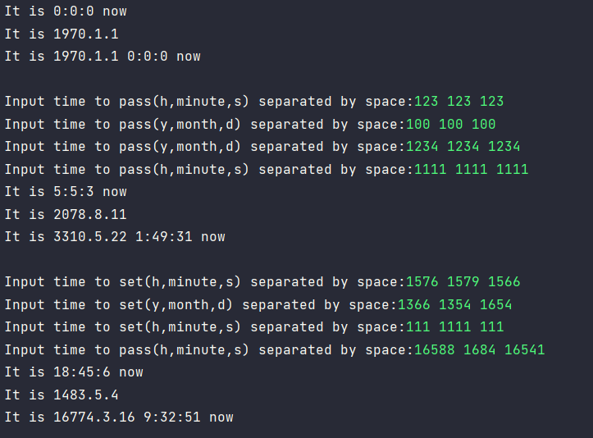
二、实验过程中遇到的问题及解决办法。
时钟和日历进位时需要连带考虑高位，CalendarClock类通过调用继承的Clock和Calendar中已实现的函数快速完成所需功能。
三、实验总结。
较好的实践了类的继承，对类的多态等概念有了更深的了解。

